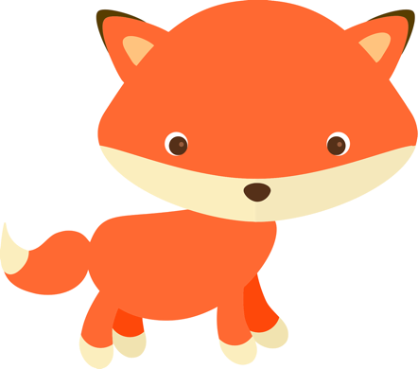**Easterling Primary School** 

**Supply List 2022-2023**

|  |  |  |
| --- | --- | --- |
| **Kindergarten** | **First Grade** | **Second Grade** |
| Box of any size Ziplock bags  2 packs of #2 pencils  2 plastic pocket folders with 3 prongs  1 package dry erase markers  3 glue sticks  1 pack of crayons  1 composition notebook (no spiral please)  Earbuds or headphones  At least 2 boxes of tissues  Personal refillable bottle of hand sanitizer  Pencil pouch | Box of any size Ziplock bag  2 packs of #2 pencils  2 pocket folders  1 package dry erase markers  3 glue sticks  2 packs of crayons  4 composition notebooks (no spiral please)  Earbuds or headphones  At least 2 boxes of tissues  Personal refillable bottle of hand sanitizer | Box of any size Ziplock bag  2 packs of #2 pencils  2 pocket folders  1 package dry erase markers  3 glue sticks  2 packs of crayons  4 composition notebooks (no spiral please)  Earbuds or headphones  At least 2 boxes of tissues  Personal refillable bottle of hand sanitizer |
| Uniform:  Polo Shirt- Kelly Green  Khaki pants, capris, skirts, shorts, and skorts | Uniform:  Polo Shirt- Butter Yellow  Khaki pants, capris, skirts, shorts, and skorts | Uniform:  Polo Shirt- Royal Blue  Khaki pants, capris, skirts, shorts, and skorts |